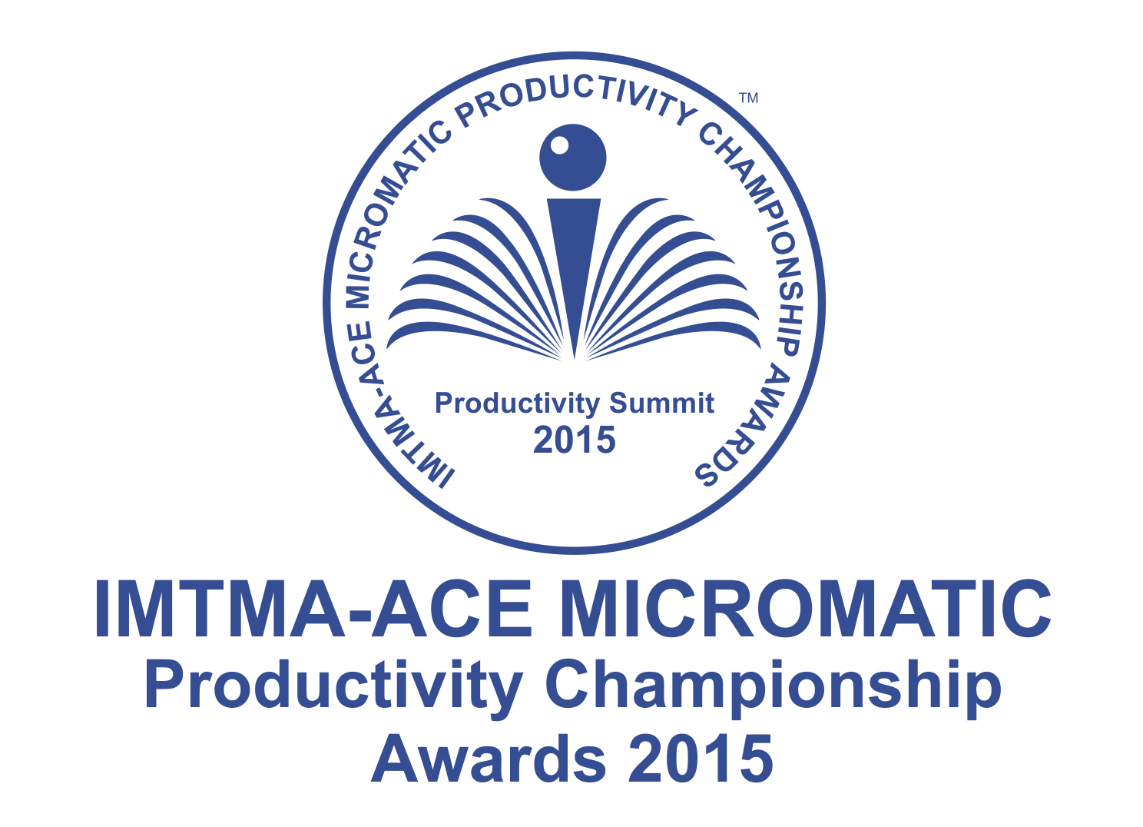 | COMPETITION ENTRY FORM
Company Name:

Address of Unit / Plant:

Annual turnover of Unit/Plant (FY 2013-2014)

Rs.………………..Crore(s)/ annum

 | Name of principal author / project leader:
 | Designation :
 | Mobile no.:
 | Email ID *:
Please read the Rules and Guidelines governing the competition carefully before filling the Entry Form

1.Title of your Project:

2. Project implementation Date (MM/YY): ……………………….

a) Is it in continued operation now (Yes/No) :

ABSTRACT OF CASE STUDY
3. Please describe your project covering the following (not exceeding 200 words)
- Problem statement
- Tools and Techniques deployed
- Solution Implemented

4. What makes your project unique? Describe the innovation in maximum 2 sentences.
5. Give up to 4 important benefits from the project, in quantified terms.

- Financial benefits to your organization …………………… Rs./annum (Mandatory Field)
Company Authorization
We certify that the contents of the above abstract are factually correct and we agree to depute our team to make a final presentation at the National Productivity Summit (scheduled in 19-21 November 2015 at Gurgaon) in case this entry is short listed for final evaluation of the award.

Further we also certify that this case study was not submitted for any of the previous IMTMA Productivity Championship Awards Competition. We hereby agree to abide by the rules governing the competition.

Name : Designation :
Date :

- All Fields need to be mandatorily filled and cannot be left blank.
- To download and submit your entry form please visit IMTMA productivity portal www.productivity.imtma.in
- Specimen case studies are available on the portal.
- Last date for submission of entries is extended to 15th June 2015.

*All future communications will be sent to the principal author/project leader’s email ID.

Rules & Guidelines governing the competition

LAST DATE FOR SUBMISSION OF ENTRY IS EXTENDED TO 15th JUNE 2015

- Participation in this competition is FREE.
- Individuals or teams who have made substantial contribution to improve productivity in metalworking industries can compete.
- Case studies must clearly describe actual implementation of productivity improvement projects in metalworking industries.
- Companies are encouraged to submit case studies that have made substantial impact on the operations rather than small improvements. Kaizens/ standalone projects with use of isolated tools / techniques may not be considered.
- Sample / specimen case studies are available on IMTMA Productivity portal www.productivity.imtma.in to guide participants to submit their case study more appropriately.
- Projects involving IT, Design or other similar applications in metal working industry can also be submitted.
- Case studies must be submitted by the companies that have implemented productivity improvement projects specifically in their units. Representation of any other company’s projects are not eligible.
- Projects having application of standard products for productivity improvement / service plugins that are commercially available will not be considered.
- To participate, please submit your case study entry online on the IMTMA’s Productivity Portal www.productivity.imtma.in.
- Best entries will be awarded cash prizes, a trophy and a certificate. Multiple or partial awards may also be given. Cash prizes will be awarded to Team Members.
- Organizations may submit more than one entry from one location or from different locations, but each of them should be distinctly different. Similar or same entries will be disqualified.
- Author(s) of the entry must have been directly responsible for the work presented in the entries.
- Project must have been implemented and put into regular operation for a minimum period of one year prior to March 2015 and not earlier than January 2012. Abstract of projects that were submitted for the previous IMTMA Productivity Summits should not be resubmitted.
- No Charts / PPT / Illustration should be submitted at the abstract stage.
- Entry forms which do not give structured information as per the prescribed format stand the risk of disqualification.
- Financial gains claimed by the projects should be certified by the top management of the organization and may be subject to verification by the evaluation team.
- No request for confidentiality will be entertained. The case studies may be published at the National Productivity Summit and distributed to delegates attending the event. IMTMA reserves the right to publish your case study in Written or Electronic Form.

- The entry form will be screened by an independent Technical Evaluation Committee. Author(s) / project leader(s) of shortlisted entries will be informed by IMTMA regarding the next step in the evaluation process. The selection committee reserves the right to accept or reject an entry without assigning any reasons thereof.
For any queries please contact:
Mr. Abhishek
INDIAN MACHINE TOOL MANUFACTURERS’ ASSOCIATION
C/o Bangalore International Exhibition Centre (BIEC)
10th Mile, Tumkur Road, Madavara Post
Bangalore – 562 123
Tel: 080-66246829/6600
- Detailed Case study presentation:
Entries that are selected for the second round of evaluation will be asked to submit a detailed eight page case study which must cover the following aspects:
- Problem identification
- Data collection
- Analysis and development of solution (includes drawings/ video clips/ photographs)
- Implementation
- Benefit to organization – improvement in productivity achieved in quantified terms
- Institutionalization of change (how it is done?)
- Innovation features
- Scope for horizontal deployment in organization and for wider use in industry
- Entries selected for the final round will be required to make a presentation of their case study at National Productivity Summit 19-21 November, 2015. The presentation must be made in English language only.
- Judging of entries:
Entries will be judged by an independent committee of experienced and eminent professionals in the metalworking industry. IMTMA and ACE MICROMATIC will not have any role in judging of Entries. The entries will be evaluated on the basis of content, quantified benefits to the organization, applicability across industries, originality, innovation, novelty of concept and so on.
Projects may be validated onsite by the Jury or their representative as part of the evaluation process, if required.

Evaluation process:
Call for entries

Screening of entries received from companies
Call for detailed 8 page case studies from selected entries of companies
Evaluation of detailed 8 page case studies
Winners are crowned as Productivity Champions 2015
Selected finalists will present their case studies live at National Productivity Summit 19-20 November 2015, Gurgaon
Start
End
Last date for submission of entries is 15th June 2015

Indicative Productivity Improvement Projects

Productivity Through Quality Improvement

- Real time/in-process metrology
- Machine and process capability
- Achieving Zero defect
- 6 Sigma projects
- How productivity has improved due to quality improvement

Manufacturing System Redesign

- Cellular manufacturing
- Factory within factory
- Applying theory of constraints
- Reducing throughput time, Minimize setup/ load/ unload times
- Quick changeover

Better Asset Utilization

- Maximize overall equipment efficiency
- TPM
- Space optimization
- Inventory management
- Smart application of CAD /CAM
- Leveraging IT
- Product Redesign
Optimizing Metal Working Process

- Metal removal process, Metal forming process, Assembly
- Finishing operations Optimizing process parameters
- Utilizing optimum capabilities of machine & accessories
- Deburring & Cleaning
- Tool management
- Work holding

