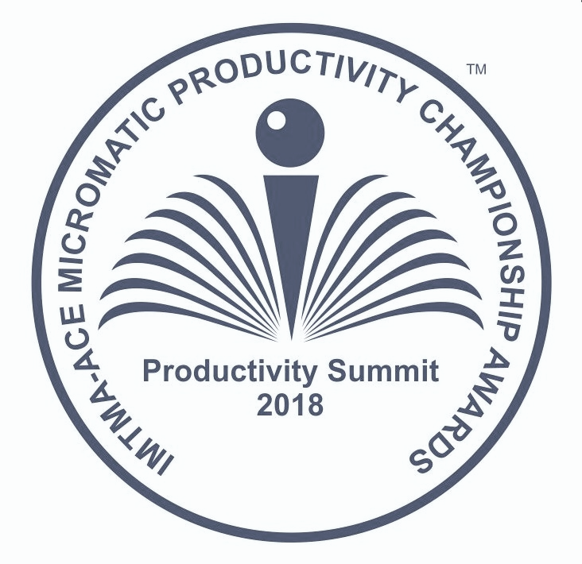

IMTMA - ACE MICROMATIC
Productivity Championship Awards 2018

Rules & Guidelines governing the competition

Competition open to companies engaged in the manufacture of Engineering products / Components.

- The objective of Productivity Summit is to boost productivity in Indian manufacturing space and share knowledge and experience.

- Participation in this competition is FREE. Please submit your case study through productivity portal www.productivity.imtma.in

- Case study/Project must be from manufacturing industries producing Engineering products / Components.

- The format of the competition has now been restructured to showcase competitiveness at the organizational level.

- Companies must submit Project / Case study that will showcase and highlight breakthrough achievements that have brought significant competitive advantage to the company. The project must clearly bring out the Value Creation and results achieved.

- While companies can send multiple entries per plant / manufacturing location, please note that only ONE best entry shall be considered for evaluation.

- Project must have been implemented and put into regular operation for a minimum period of one year, but not earlier than January 2014. Entries that were submitted for the previous IMTMA Productivity championship competition must not be resubmitted. Such entries will be summarily disqualified.
Note:
  - Minor improvements, Kaizens, will not be considered.Participants are expected to submit case studies that have brought in significant improvements to their business.
  - Projects having application of standard products for productivity improvement / service plugins that are commercially available will not be considered.

- Companies must submit their entry(s) strictly in the format as per Annexure A (enclosed). Entries without structured information on the project / case study stands the risk of disqualification.
- The selected case study / project must be presented at the National Productivity Summit 2018 scheduled on
24-25 August 2018, Chennai by a member of the Senior Management of the organization responsible for the project implementation. However he/she can be supported by their team members. The presentation must be made in English language only.

- Entries will be judged by an independent committee of experienced and eminent professionals in the manufacturing industry whose decision will be final. While significant weightage will be given to the conceptualization, link to business need, associated impact, value creation to stakeholders and business sustainability parameters, the other criteria for evaluation will also include analysis, determination of requirements, generation and evaluation of alternatives, innovativeness and the thoroughness of planning and implementation. Neither IMTMA nor ACE MICROMATIC will have any role in judging of entries. The committee reserves the right to accept or reject an entry without assigning any reasons thereof. Therefore IMTMA is not obliged to provide reasons for rejection.

- Projects may be validated onsite by the evaluation team as part of the evaluation process, if required.

- Winners will be awarded cash prizes, a trophy and a certificate. Multiple or partial awards may also be given. Cash prizes will be awarded to individuals / Team Members.

- Applicants are assured of the confidentiality and their IP rights. Presentations at the summit can contain concepts and broad contours of the project without disclosing confidential information.

For any queries please contact:
Mr. Mahesh Gopalakrishna
Deputy Director
INDIAN MACHINE TOOL MANUFACTURERS' ASSOCIATION
C/o Bangalore International Exhibition Centre (BIEC)
10th Mile, Tumkur Road, Madavara Post, Bangalore – 562 123
Website : www.imtma.in
Tel: 080-66246716/6600, Mob: 9886611007

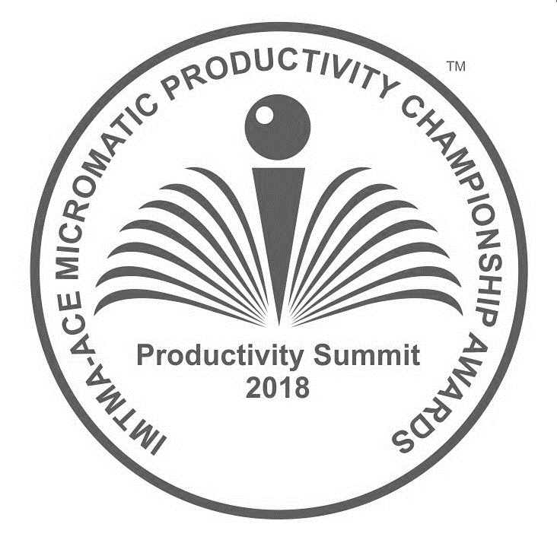
Indian Machine Tool Manufacturers' Association
Head Oﬃce : 10th Mile, Tumkur Road, Madavara Post,
Bangalore – 562123, Karnataka, India.
T: 080-6624 6716 / 6624 6600 E : gmahesh@imtma.in W : www.imtma.in
IMTMA-ACE MICROMATIC PRODUCTIVITY CHAMPIONSHIP AWARDS 2018
GUIDELINES FOR SUBMISSION OF CASE STUDY / PROJECT Competition open to companies engaged in the manufacture of
Engineering products / Components

Contestants are advised to read the following guidelines carefully before filling in the format
FORMAT FOR SUBMISSION OF CASE STUDY / PROJECT
Title of Case Study / Project:
1  2  3 | Name of company:  Address of the Plant / Site location:  Tel No.:  Company Turnover (in Rs. Cr)  No. of employees:  Industry sector (Pl. specify):  Name of the project leader:  Designation :  Mobile No.:  Email ID:  Alternate contact person:  Designation :  Mobile No.:  Email ID:  Project implementation  Start date :  End date :  Is it in continuous operation now? (Yes/No) :  Certificate by the Head of Company/ Business Unit/ Division:  We certify that the project described here is factually correct and is in continuous operation.  We confirm that we have read the rules and guidelines governing this competition and agree to abide by the same.  We agree to depute our senior management team to make a final presentation at the National Productivity Summit 2018 scheduled on 24-25 August 2018 at Chennai in case this entry is short listed for final evaluation of the award.  Signature:_____________________________  Name :__________________________________  (Head of Company/Business Unit / Division)  Designation: _____________________________  Date:____________________________________

ANNEXURE : A

IMTMA-ACE MICROMATIC PRODUCTIVITY CHAMPIONSHIP AWARDS 2018
GUIDELINES FOR SUBMISSION OF CASE STUDY / PROJECT (Contd.)
4  5  6 | Contestants are encouraged to include charts/ tables/ graphs/sketches/ photos / URL linked videos and other graphical illustrations to bring out the merits of their project / case study. Bring out the situation Before and After project implementation.  Authors may use their discretion to elaborate on the parameters as appropriate to the case study, subject to a maximum length of Eight (8) A4 size pages. Font size should not be smaller than Arial 11. Only MS Word format is to be used.  The filled in format should be uploaded in the productivity portal www.productivity.imtma.in on or before 7 April 2018. Please ensure that the file size being uploaded does not exceed 20 MB. Subsequently the hard copy of the entry duly signed and certiﬁed by the senior management should be sent to IMTMA's Bangalore oﬃce at the above address.

IMTMA-ACE MICROMATIC PRODUCTIVITY CHAMPIONSHIP AWARDS 2018
FORMAT FOR SUBMISSION OF CASE STUDY / PROJECT
Contestants are expected to present the case study on the following parameters within Eight (8) A4 size pages. ALL PARAMETERS LISTED BELOW MUST BE ADEQUATELY ADDRESSED AND CANNOT BE LEFT BLANK.
1  2  3  4  7  8 | Your case study will be evaluated based on following criteria (as per the weightage points listed below) relative to the other entries.  (a) Trigger for the project (b) Solution Generation & Innovation, (c) Implementation,  (d) Results / Impact, (e) Environmental impact, (f) Scope for horizontal deployment and  (g) Any other merits  Shortlisted case studies will make final presentation at the National Productivity Summit 2018.  Brief Description of the project.  Please state the objectives, scope of the project, its context, and the challenges under which the project was taken up. Of course, this is a Productivity contest, so the principal aim must be to raise productivity of machine/line, people or material, or all of these. The challenges inherent in the project could be brought out.  Trigger for the project. (10 points)  What made your company to take up this Project? Describe briefly.  Project triggers could be business need, customer requirement, business sustainability, competition, competitive advantage, need to minimize investment, optimize manpower, speed up outcomes or avert unsafe or poor environmental conditions etc. Please list the targets that were expected to be fulfilled by the project  Solution Generation & Innovation. (20 points)  How did you generate the solution which you implemented?  Present your analysis with data, or show how alternative solutions were developed and evaluated. This is a step that requires depth and skillful use of data and techniques. Solutions could be engineering or technology oriented, or application of industrial engineering, or statistical methods or combinations of these. The engineering and detailing of the chosen solution could be elaborated.  Implementation. (20 points)  Describe how the selected solution was implemented.  Some of the aspects could be implementation involving communication, training of people, resource utilisation, Unique or Innovative approaches or managing risks. You could show thoroughness in implementation and how you overcame technical or managerial challenges. In some cases, implementation needs consensus building and team work, and these too could be explained.

IMTMA-ACE MICROMATIC PRODUCTIVITY CHAMPIONSHIP AWARDS 2018
FORMAT FOR SUBMISSION OF CASE STUDY / PROJECT (Contd.)
5.  6  7  8 | Results / Impact. (20 points)  Value Creation and Business Results.  Explain how the company has benefited by enhanced competitive advantage and continued business sustainability.  You could show the overall impact of your project on the company – both financial and non-financial. What value was added? Is there a competitive advantage, in terms of price or quality, or ability to deliver quantities? Does it impact market standing or market share? Has a new technology been developed? Or a management method or technique? Is there external recognition within or from outside the country? Are there patent applications or other IPR benefits? How sustainable are these outcomes over a period of time?  Environmental impact. (10 points)  What is the impact of your project on environment? E.g. Energy savings, reduction/Elimination of toxic material or waste generated, preserving natural resources, user and societal safety enhancement, mitigation of pollution/emission effects, reduction in Carbon footprint and so on.  Scope for horizontal deployment. (10 points)  Can the ideas, principles, concepts or techniques developed by you be implemented in other areas in your company and in similar / other industry? Describe.  Any other merits. (10 points)  Give any other information that supplements your project / case study to be a winning entry.  Note: Please consider the above points as guidelines and elaborate as appropriate. Please note that your entry should not exceed Eight (8) A4 pages.

